Friday,
September 24,
2021

in MEXICO, MO

Sponsored by

Consolidated Electric Cooperative
Moberly Area Community College

5th Grade

4th & 5th
GRADES
8:30 OPEN (ALL GROUPS REGISTER at JC Shelter in Robert S. Green Park)
*Meet your tour guide and get information for your tour.
*GIFT BAGS at Shelter on departure from Consolidated Electric Coop.
9:00 Guided Tours begin, Schoolhouse, Games, Church Music
11:45-12:15 (SUGGESTED TIME) Lunch-picnic areas or under trees.
Coolers may be placed on tables in the Registration Shelter
12:15-1:15 Last guided tours, schoolhouse, church
1:30 CLOSE OF EDUCATION DAY (Leave the grounds by 2:30 PM)

LIMIT 700 STUDENTS who have registered by the cut-off date.
PLEASE COMPLETE REGISTRATION INFORMATION by Friday, Sept. 10;
Tori Webber; twebber4.tw@gmail.com; 573-473-7183. Provide information for each teacher from your school.
School Name_____________________________________Address___________________________________________
City: ______________________ Zip __________ Estimated Time of Arrival: __________ Departure: _________
TEACHER’S NAME: ______________________________ PHONE # __________________ EMAIL: ____________________________
# STUDENTS_____ #PARENTS:____ for each class.

EXTRA INFORMATION
- GUIDED TOURS-1 hour – approximately 6 camps @ 10 minutes each.
- SCHOOLHOUSE & MUSIC IN THE CHURCH groups change every 15 minutes.
-SIGN-UP TIME is in front of each building.
-NO STROLLERS in the Schoolhouse.
-Schoolhouse space in is limited to groups of 30 total. Please have one adult with the group.
For large groups parents can wait outside and allow children the opportunity to utilize available space.
- SHOPPING is not included in the guided tour. Students are welcome to buy souvenirs under your guidance.
- CONSESSIONS are available.
- CHILDREN MUST BE WITH AN ADULT AT ALL TIMES.
- GRACELAND MANSION IS CLOSED. PUBLIC IS NOT ALLOWED ON THE PORCHES OR INSIDE TODAY. Thanks!
- PORTA-POTTIES are on-site.
- SIMMONS STABLES is off-site only 2 blocks away. This is not part of your Guided Tour. Contact Mary Littrell to set up time and find out what activities are planned. 573-473-2521 grl@ktis.net www.saddlebredhalloffame.org/

BUS INFORMATION: FROM MULDROW. WEST on Breckenridge St.. NORTH on Grove St.. Children get off bus at Jaycee Shelter. Buses then move forward to MISSOURI ST. Go North or South on Missouri to find a parking space. Coolers and Medicines can be stored at the shelter for the classrooms. AUDRAIN COUNTY HISTORICAL SOCIETY 501 SOUTH MULDROW
Your GUIDED TOUR will allow your classroom access to see the REENACTORS! You will have approximately 6 stops in the hour. Some of the sites include: Colonial, Civil War, Vikings, Mountain Men, Wild West Cowboys, Native Americans, Pony Express, Vietnam USMC, WWII, WWI, French & Indian War, Medieval Swordsmen, Pirates, etc.
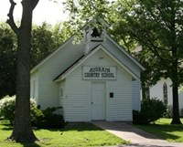
THINGS TO DO BEFORE OR AFTER YOUR GUIDED TOUR*
- SCHOOLHOUSE
Every 15 minutes a new “class” begins. SIGN UP on the easel in front. Teachers/helpers need to stand in back to allow children the seats inside. NO STROLLERS.
- MUSIC
Every 15 minutes a new round of favorite songs begins. The church can seat about 50 folks. Come on in to join the song!
- GAMES
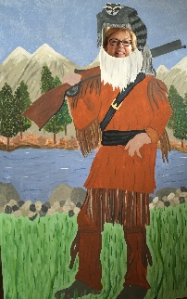
Old-tyme games are housed under the pavilion. This is a great place to relax and maybe learn a new game.
- PICTURES
Take some fun pictures of your students in the character figures located near the Stables.
- SHOP
There are several stores on the grounds that the students enjoy seeing.
- Wild BIRD Sanctuary
The Bird Area is a fun place to see birds up close with Conservation Agents on hand to explain. (Shhhhhhh….quiet by the birds…)
- PICNIC TOGETHER
Bring your lunches and find a spot under the shelter. You may leave coolers here when you register.
- PARK PLAYGROUND NEAR THE SHELTER
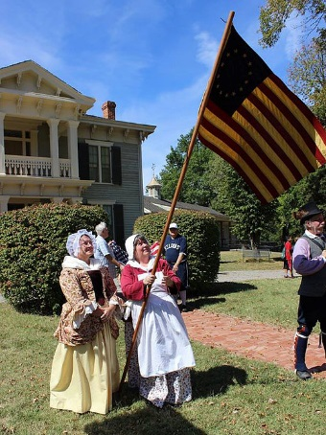
- MAKE AN APPOINTMENT WITH SIMMONS STABLES IF YOU WANT TO WALK 2-3 BLOCKS OFF-SITE.

